31st January 2018

Dear Fellow Archers,

Greenwood Osterley Archers would like to invite you and members of your club to participate in our St. George’s May Day Shoot.

St. George’s Day Tournament Organisers: Sailesh & Meera Shah

The Shoot is to be held on Bank Holiday Monday: Monday 7th May 2018.

Address: Grasshoppers RFC, Macfarlane Lane, off Syon Lane, Osterley, TW7 5PN

Assembly: 10:00am Sighters: 10:15 am

Rounds: St. George, Albion and ALL Windsor Rounds (no age restrictions)

Awards: There will be a hidden score prize for each target. Colour Prize for each colour will be awarded.

Raffle: There will be a raffle tickets available through out the day. Raffle will take place after the shoot is finished.

Members of your club are invited to take part, at a cost of £8.00 for adults & £6.00 for juniors.

Please make cheques payable to GOA, pay us on the day in cash or make a direct bank transfer to the following bank account with your name as reference:

Account Name: Greenwood Osterley Archers
Account: 1390 7763
Sort Code: 77-91-64

The shoot is ideal for archers of all experiences & abilities shooting either Compound, Recurve, Longbow or Barebow.

Entries to: Tournament Organiser (Sailesh & Meera Shah)
9 High Street, Cranford, TW5 9RN
Mobile: 07747463256
Email: greenwoodosterleyarchery@gmail.com

Please Note:

- All Carbon arrows are not allowed at this shoot
- There will be no provision for crossbows.
- Longbows are welcome, but archers must be members of AGB.
- ABG cards may be requested at Registration.
- Greenwood Osterley Archers and the Grasshoppers RFC cannot accept claims for any loss or damage sustained at the venue.
- Greenwood Osterley Archers will not be liable for arrows damaged in the target or because of pass-throughs.
- No Trolleys to be taken across the 1st Team Pitch. Please walk around the pitch.
- Access to the shooting field from 9am.
- The Bar will be open at lunchtime & after the shoot. There will be light refreshments on the day. Bring your own lunch.
- Photography Registration form will be available on the day.

Please can you indicate below the members who wish to take part and the rounds they would like to shoot?

I look forward to receiving these details together with the relevant fee by Monday 30th April 2018.

A map is attached, Target Lists will be sent by email.

Club Name: ______________________

Your Contact Number: _____________________________

Your Email Address: _________________________________
Name | Round | Snr/Jnr | Ladies/ Gents | Bow Type (Rec/Comp/ LBow/ BBow) | AGB N.O | Email Address

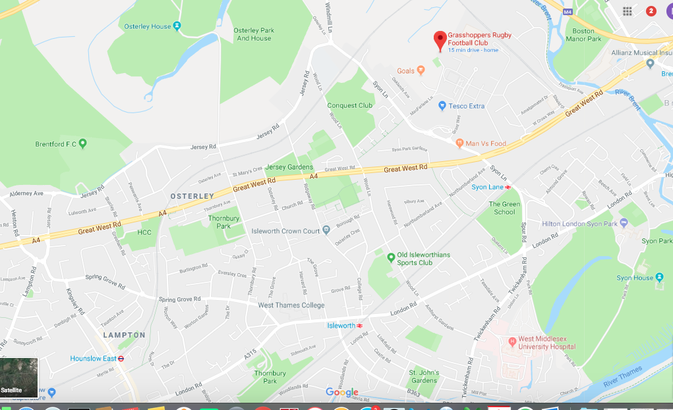
Map:

Alternative Travel:
H91 Bus from Hounslow West to Gillette Corner, then turn left at Shell Petrol Station and continue walking down to Macfarlane Lane and turn right and carryon Macfarlane Lane till you reach Grasshoppers Clubhouse.

Nearest tube station is Osterley Station. You can take H91 bus to Gillette Corner and then turn left at Shell Petrol Station and continue walking down to Macfarlane Lane and turn right and carryon Macfarlane Lane till you reach Grasshoppers Clubhouse.

You can take H28 bus from Hounslow Bus Station to Osterley Tesco and then walk down for about 6 minutes to Grasshoppers Clubhouse.

Syon Lane Station is also walking distance from Grasshoppers. From Syon lane Station walk straight on to Syon Lane and carry on until you reach Macfarlane Lane and turn right into Macfarlane Lane and carry on walking until you reach Grasshoppers Clubhouse.

